Network Constrained Carbon Emission Modeling Based on Pandapower (open-source tool for power system modeling)
The network-constrained power system model implemented in this code represents the Tokyo Metropolitan Area (TMA) as a set of fourteen interconnected geographic zones, each modeled as an aggregated electrical subsystem that interacts with neighboring zones through a high-voltage transmission network. The modeling approach adopts a hierarchical abstraction, in which intra-zonal electrical details are aggregated into a single low-voltage representation, while inter-zonal power exchanges are explicitly constrained by transmission lines, transformers, and AC power flow physics.
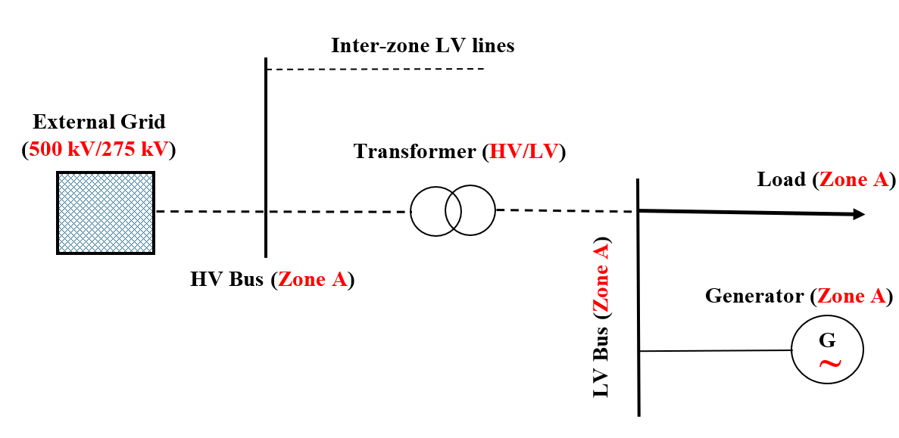
Figure 1: Single zone electrical power network
Figure 1 illustrates the power system architecture of a single zone, where generation and load are connected at a low-voltage (LV) bus. This LV bus is linked to the regional transmission system through a single high-voltage (HV) bus via a transformer. The HV buses of all zones form a meshed transmission network across the TMA, featuring multiple voltage levels and corridors as shown in Figure 2.

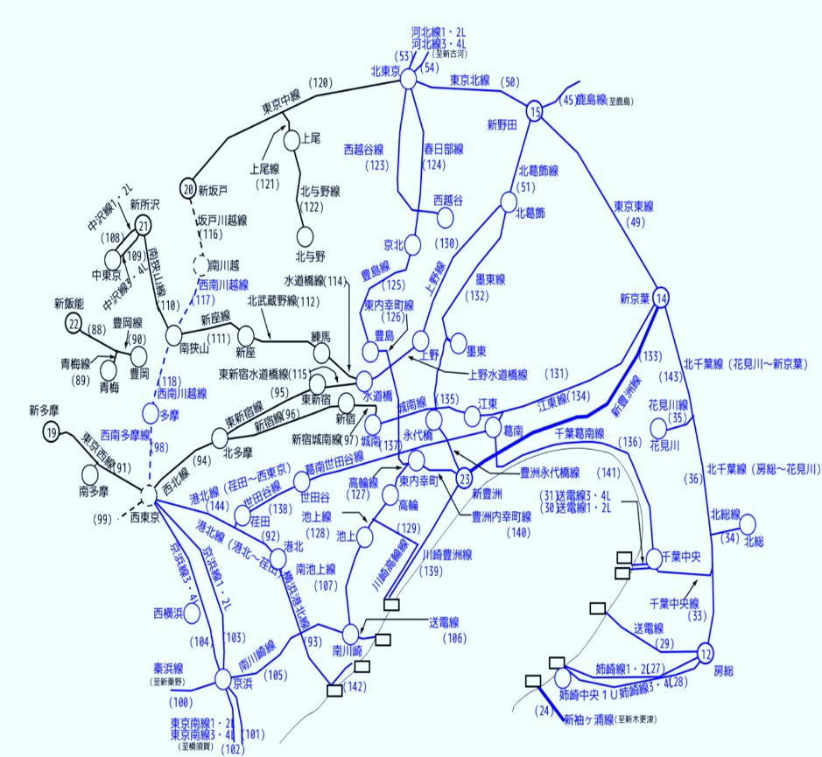
Figure 2: Meshed transmission network in the TMA adopted from website [1]
Within the main function, Zonal_Power_Network, the electrical network is constructed once and remains fixed throughout the simulation horizon. Each zone z contains two buses: the LV bus represents the distribution-level aggregation point where all zonal electricity demand and generation technologies are connected, including thermal generators, renewables, and other defined generation types in the merit order; the HV bus serves as the interface with the regional transmission grid. This separation allows the model to distinguish between local balancing within a zone and power exchanges between zones, while still respecting the physical limitations imposed by transformers.
The LV and HV buses of each zone are connected by a transformer whose rated apparent power reflects the installed capacity of the zone. Electrically, this transformer enforces the constraint that the power injected by generators or withdrawn by loads at the LV level must pass through a finite-capacity interface before entering or leaving the transmission network. Mathematically, the transformer imposes a constraint of the form:
$$\left|P_{z}^{LV→HV}\right|≤P_{z}^{trafo,max}$$ | (1)
where $P_{z}^{LV→HV}$​ is the active power flowing from the LV bus of zone z to its HV bus, and $P_{z}^{trafo,max}$​ is derived from the installed megawatt capacity of that zone. During AC power flow calculations, transformer loading is monitored, and congestion arises when this limit is exceeded.
Table 1 summarizes the characteristics of transformers connecting each zone’s LV bus to its HV bus, including the HV and LV voltages, installed capacity, and operational capacity. These transformer ratings determine the maximum power a zone can inject into or withdraw from the transmission network, thereby enforcing intra-zonal export/import limits.
Table 1: Transformer characteristics per zone obtained from website [1]
Zone | HV Bus (kV) | LV Bus (kV) | Installed MW | Operating MW
Tokyo wards | 275 | 154 | 41,597 | 35,454
Tama area | 275 | 154 | 21,657 | 16,591
Yokohama | 275 | 154 | 9,262 | 6,984
Kawasaki | 275 | 154 | 2,431 | 2,065
Sagamihara | 275 | 66 | 1,799 | 1,457
Kanagawa | 500 | 154 | 27,958 | 23,551
Saitama | 275 | 154 | 8,197 | 6,800
Southern Saitama | 275 | 154 | 2,749 | 2,543
Northern Saitama | 500 | 154 | 24,338 | 21,336
Chiba | 275 | 66 | 1,344 | 1,198
Northern Chiba | 154 | 6.6 | 758 | 758
Southwestern Chiba | 154 | 6.6 | 758 | 758
Eastern Chiba | 275 | 154 | 21,534 | 18,405
Southern Ibaraki | 275 | 154 | 3,710 | 3,919

The HV buses of different zones are interconnected according to the actual transmission topology of the TMA. Each inter-zonal connection may consist of multiple parallel transmission lines operating at different voltage levels. Line electrical parameters, such as resistance and reactance, are scaled according to voltage level and geographic distance. Thermal limits are enforced through a maximum allowable current, $P_{l}^{max}$, which defines an active power limit:
$$P_{l}^{max}=\sqrt{3}×V_{l}×I_{l}^{max}$$ | (2)
where $V_{l}$​ is the line voltage and $I_{l}^{max}$​ is the thermal current limit. This ensures inter-zonal power transfers are physically feasible, allowing congestion to occur on heavily loaded corridors.
Table 2 shows the total transmission capacity within each zone at different voltage levels (22 kV to 500 kV). These capacities define the physical limits for intra-zonal power flow and provide the basis for enforcing thermal constraints and congestion checks in the AC network.
Table 2: Voltage-level line capacity per zone (MW) obtained from website [1]
Zone | 22 kV | 66 kV | 154 kV | 275 kV | 500 kV
Tokyo wards | 0 | 16,136 | 21,724 | 3,300 | 3,000
Tama area | 20 | 16,136 | 4,832 | 3,300 | 3,000
Kanagawa | 0 | 35,191 | 30,587 | 3,850 | 4,000
Kawasaki | 0 | 35,191 | 30,587 | 3,850 | 4,000
Sagamihara | 0 | 35,191 | 30,587 | 3,850 | 4,000
Yokohama | 0 | 35,191 | 30,587 | 3,850 | 4,000
Chiba | 60 | 33,303 | 8,753 | 2,750 | 3,000
Eastern Chiba | 60 | 33,303 | 8,753 | 2,750 | 3,000
Northern Chiba | 60 | 33,303 | 8,753 | 2,750 | 3,000
Southwestern Chiba | 60 | 33,303 | 8,753 | 2,750 | 3,000
Northern Saitama | 40 | 28,598 | 33,063 | 2,750 | 3,000
Saitama | 40 | 28,598 | 33,063 | 2,750 | 3,000
Southern Saitama | 40 | 28,598 | 33,063 | 2,750 | 3,000
Southern Ibaraki | 0 | 21,168 | 12,734 | 2,750 | 2,500

One zone, Chiba, is connected to an external grid and designated as the slack bus. This external grid anchors system voltage magnitudes and phase angles while absorbing residual imbalances between total generation and demand caused by numerical tolerances. Importantly, the slack bus does not receive artificially assigned emissions; carbon emissions are calculated based on actual zonal generation and traced power flows.
Table 3 provides the number of high-voltage lines connecting each pair of zones at 500 kV and 275 kV, representing the inter-zonal transmission infrastructure. These interconnections constrain power flows between zones and shape network-constrained dispatch and carbon emission allocation.
Table 3: Representative inter-zonal connections, estimated from website [1]
From → To | 500 kV | 275 kV
Tokyo wards → Tama area | 5 | 10
Tokyo wards → Yokohama | 3 | 6
Tokyo wards → Kawasaki | 3 | 6
Tokyo wards → Saitama | 3 | 7
Tokyo wards → Southern Saitama | 3 | 7
Tokyo wards → Chiba | 2 | 4
Tokyo wards → Northern Chiba | 2 | 4
Tokyo wards → Southwestern Chiba | 2 | 4
Tokyo wards → Southern Ibaraki | 5 | 10

Once the network is constructed, the model proceeds through a sequence of hourly simulations. At each time step, zonal electricity demand $D_{z}(t)$ and zonal generation $G_{z}(t)$ are read from input data. An initial economic, network-agnostic balancing is performed to determine ideal power exchanges between zones. This reflects how a zonal electricity market would clear if transmission constraints were ignored. The net power balance for each zone is computed as
$∆_{z}\left(t\right)=G_{z}\left(t\right)-D_{z}(t)$ | (3)
If $∆_{z}\left(t\right)>0$, the zone has a surplus and can export power; if $∆_{z}\left(t\right)<0$, the zone has a deficit and must import power. These surpluses and deficits form the basis for the idealized inter-zonal power exchange calculation.
The function handle_power_balance implements a multi-stage balancing algorithm. Initially, surplus zones attempt to export directly to neighboring deficit zones. If neighbors cannot absorb the entire surplus, the algorithm searches for deficit zones reachable through multiple hops using a weighted breadth-first strategy that favors transmission paths with lower aggregate “cost.” While this cost is not a full electrical impedance, it represents relative transmission attractiveness based on available line capacities.
During the ideal exchange process, generation is adjusted according to a predefined merit order. Generators are ordered by increasing carbon emission factor, and exports are supplied first by higher-emission generators. If $P_{z,g}$​ denotes generation of type g in zone z and ${EF}_{g}$​ denotes its emission factor, then the ideal local emissions before network constraints are
$E_{z}^{ideal}\left(t\right)=\sum_{g}{(P_{z,g}^{used}(t)×{EF}_{g})}$ | (4)
where $P_{z,g}^{used}$​ excludes the portion of generation curtailed to supply exports. This economic assumption prioritizes displacement of dirtier generators for exports.
The ideal zonal exchange matrix $P_{z→k}^{ideal}(t)$ specifies how much power each zone would export to every other zone in the absence of physical constraints. This matrix represents a target dispatch pattern, not yet physically feasible.
In the next stage, the ideal dispatch is mapped onto the physical network. Zonal generation values are assigned to LV-connected generators, while zonal loads are assigned to the same LV bus. Exports implied by the ideal exchange matrix are translated into adjustments of generator outputs, respecting the merit order, so that net injections at each zone’s HV bus match the intended export or import.
A full AC power flow calculation is then performed using pandapower. The AC formulation enforces Kirchhoff’s laws, voltage constraints, and thermal limits on lines and transformers. The fundamental power balance equation at each bus i is
$P_{i}^{gen}-P_{i}^{load}=\sum_{j}{(\left|V_{i}\right|×\left|V_{j}\right|×(G_{i,j}\cos\left(θ_{i,j}\right)+B_{i,j}\sin\left(θ_{i,j}\right)))}$ | (5)
with analogous equations for reactive power. If any line or transformer exceeds 100 percent loading, the system is considered congested.
When congestion occurs, the model enters an iterative rebalancing process. Generator outputs in zones associated with overloaded elements are uniformly scaled down by a factor related to the maximum overload. This process is repeated until either all overloads are resolved or a maximum number of iterations is reached. If the AC power flow fails to converge, a fallback procedure redistributes surplus power proportionally among deficit zones without relying on network physics, ensuring continuity of the simulation.
Once a feasible power flow solution is obtained, the model determines the actual origin of electricity consumed in each zone. This is accomplished through the trace_power_origin function, which applies the proportional sharing principle. Each generator injects its output into the network tagged with its zone of origin. As power flows through lines and transformers, these tags are propagated proportionally to the magnitude of power flows. If a bus has total outgoing power F_{b}​ and a fraction α_{b,o}​ of that power originates from zone o, then the contribution of zone o to a downstream bus j is
$P_{b→j}^{(o)}=α_{b,o}×P_{b→j}$ | (6)
By iterating this process across the network, the model computes how much power from each origin zone supplies the load in every destination zone. This tracing enables a physically grounded allocation of imported emissions. For each zone z, local emissions are calculated from the portion of local generation that actually serves local load, excluding exported power. Imported emissions are calculated as
$E_{z}^{import}(t)=\sum_{o}{(P_{o→z}^{actual}(t)×{\overline{EF}}_{o}(t))}$ | (7)

where$P_{o→z}^{actual}$​ is the traced power flow from origin zone o to zone z, and ${\overline{EF}}_{o}$ is the weighted average emission factor of exported generation from zone o. If detailed exporter-specific emission data are unavailable, a system-average value is used as a fallback. The total network-constrained carbon emissions attributed to zone z at time t are then given by
$E_{z}^{total}\left(t\right)=E_{z}^{local}\left(t\right)+E_{z}^{import}(t)$ | (8)
These values differ from ideal economic emissions because transmission constraints, congestion, and AC power flow physics modify which generators supply which loads.
In summary, the model integrates a zonal economic dispatch framework with a physically explicit AC transmission network to quantify how congestion and network topology reshape power flows and carbon responsibility in the TMA. The single-zone abstraction provides the conceptual foundation, while the regional network diagram shows how zones are interconnected. By combining merit-order dispatch, multi-hop power exchanges, AC load flow, and proportional sharing–based tracing, the model produces a realistic, network-constrained view of zonal electricity-related carbon emissions.
The following pseudocode explicitly presents the steps required to implement the network-constrained carbon emission model and highlights the fallback mechanism used when AC power flow does not converge, ensuring robustness of emission accounting.
Network constrained carbon emission modeling pseudocode
Input (Zonal demand time series D_{z}(t), zonal generation by technology G_{z,g}(t), emission factors EF_{g}, zonal transformer parameters, inter-zonal network topology, transmission distances and capacities, merit order of generation technologies, maximum network rebalancing iterations)
Initialization (executed once): |  |  |  |  | Note
 | Create empty electrical network
 | FOR each zone z:
 |  | Create LV bus for zone z
 |  | Create HV bus for zone z
 |  | Connect LV bus to HV bus via transformer
 |  | Attach load to LV bus
 |  | Attach generation units (by technology) to LV bus
 | END FOR
 | Create HV transmission lines between zones based on topology
 | Assign external grid (slack bus) to reference zone
FOR each time step t in simulation horizon:
 | FOR each zone z: |  |  |  | Assign hourly data
 |  | Set load at LV bus to D_{z}(t) |  |  | Assign hourly data
 |  | Set generation at LV bus to G_{z,g}(t) for all g |  |  | Assign hourly data
 | END FOR |  |  |  | Assign hourly data
 | FOR each zone z: |  |  |  | Compute zonal imbalance
 |  | Compute total generation G_{z}(t) |  |  | Compute zonal imbalance
 |  | Compute surplus S_{z}(t) = max (G_{z}(t) − D_{z}(t), 0) |  |  | Compute zonal imbalance
 |  | Compute deficit H_{z}(t) = max (D_{z}(t) − G_{z}(t), 0) |  |  | Compute zonal imbalance
 | END FOR |  |  |  | Compute zonal imbalance
 | Initialize ideal exchange matrix P_{ideal} (z, k) = 0
 | FOR each surplus zone z: |  |  |  | Ideal (economic) power balancing
 |  | Export surplus to neighboring deficit zones |  |  | Ideal (economic) power balancing
 |  | IF surplus remains: |  |  | Ideal (economic) power balancing
 |  |  | Find deficit zones via multi-hop routing |  | Ideal (economic) power balancing
 |  |  | Allocate exports along least-cost paths |  | Ideal (economic) power balancing
 |  | END IF |  |  | Ideal (economic) power balancing
 |  | Reduce generation according to reverse merit order |  |  | Ideal (economic) power balancing
 |  | Track ideal economic emissions |  |  | Ideal (economic) power balancing
 | END FOR |  |  |  | Ideal (economic) power balancing
 | Adjust generator outputs to reflect exports
 | Ensure generation follows merit order allocation
 | iteration = 0
 | Load Flow Converged = TRUE |  |  |  | Network-constrained AC power flow
 | WHILE iteration < max iterations: |  |  |  | Network-constrained AC power flow
 |  | Run AC power flow |  |  | Network-constrained AC power flow
 |  | IF load flow fails: |  |  | Network-constrained AC power flow
 |  |  | Load Flow Converged = FALSE |  | Network-constrained AC power flow
 |  |  | BREAK |  | Network-constrained AC power flow
 |  | END IF |  |  | Network-constrained AC power flow
 |  | Identify overloaded lines and transformers |  |  | Network-constrained AC power flow
 |  | IF no overloads: |  |  | Network-constrained AC power flow
 |  |  | BREAK |  | Network-constrained AC power flow
 |  | END IF |  |  | Network-constrained AC power flow
 |  | Scale down generators in affected zones |  |  | Network-constrained AC power flow
 |  | iteration = iteration + 1 |  |  | Network-constrained AC power flow
 | END WHILE |  |  |  | Network-constrained AC power flow
 | IF Load Flow Converged == TRUE: |  |  |  | Power origin tracing
 |  | Initialize power contribution labels at generators |  |  | Power origin tracing
 |  | Propagate contributions through: |  |  | Power origin tracing
 |  |  | transmission lines |  | Power origin tracing
 |  |  | transformers |  | Power origin tracing
 |  | using proportional sharing |  |  | Power origin tracing
 |  | Compute actual power flows: |  |  | Power origin tracing
 |  |  | Pactual (o → z) for all origin–destination pairs |  | Power origin tracing
 | ELSE: |  |  |  | Power origin tracing
 |  | Apply fallback proportional redistribution |  |  | Power origin tracing
 | END IF |  |  |  | Power origin tracing
 | FOR each zone z: |  |  |  | Emissions calculation
 |  | Compute local emissions from generation serving local load |  |  | Emissions calculation
 |  | Compute imported emissions: |  |  | Emissions calculation
 |  |  | Sum over origin zones: |  | Emissions calculation
 |  |  |  | imported power × origin emission factor | Emissions calculation
 |  | Total emissions: |  |  | Emissions calculation
 |  |  | E_{z}(t) = local emissions + imported emissions |  | Emissions calculation
 | END FOR |  |  |  | Emissions calculation
 | Save (t, z, E_{z}(t)) to output records
END FOR
OUTPUT: |  |  |  |  | Store results
 | Time series of network-constrained zonal carbon emissions |  |  |  | Store results

[1] "TEPCO lineage information (in Japanese)," TEPCO, [Online]. Available: https://www.tepco.co.jp/pg/consignment/system/index-j.html?utm_source=chatgpt.com. [Accessed 08 12 2025].

